Machine Learning approach to identify Gemstones and their shape
(April 2024)

Sachin De Silva
BEng (Hons) Software Engineering
University of Westminster
London, UK

Abstract—The gemstone business is filled with difficulties, particularly the widespread problem of distinguishing genuine gemstones from counterfeit imitations, which are frequently carefully made to look like the real thing. This deceitful method erodes consumer trust and confidence, requiring strong solutions to differentiate authentic gemstones from counterfeit ones. Moreover, the task of differentiating between different gem cuts presents a substantial difficulty, hence adding complexity to the buying process for purchasers.
To address these urgent concerns, a thorough research project focused on solving the dual problems of gemstone identification and shape recognition. By utilising advanced image processing techniques and machine learning approaches, specifically, Convolutional Neural Networks (CNNs), created a complex classification system that can effectively identify the name of the gemstone with 74% high accuracy. In addition, by employing using novel methods for identifying gem shapes with an 87% accuracy, which involve the utilisation of shape recognition and Photogrammetry principles, the aim is to equip consumers with the necessary information to make well-informed purchasing choices.
This research highlights the significance of technical innovation in reducing fraudulent practices in the gem industry. The goal is to improve transparency and rebuild trust in the gemstone industry by offering purchasers dependable tools for gemstone authentication and cut recognition. This will create a fair and secure trading environment for all parties concerned.
Keywords—Gemstone, Shapes, Image Processing, Clustering, Convolutional Neural Network, Image Segmentation, Deep Learning

Introduction
Gemstones have always fascinated mankind due to their rarity, durability, and beautiful appearance. Gemstones exude a unique allure in the domain of jewelry and adornment owing to their extensive array of hues, faceting styles, and transparency. In the past, the identification of gemstones and their shapes has mainly relied on human expertise, a process that is both laborious and subjective. However, the rise of artificial intelligence and machine learning provide a promising chance to automate this crucial task.
This research investigates the area of gemstone identification and shape recognition using a sophisticated gem analyzer that employs machine learning techniques. Our study focuses exclusively on four commonly found gem types that are prevalent in the local industry, despite the vast array of gemstone varieties that exist. By employing machine learning, our aim is to explore the feasibility of automating the identification process, therefore revolutionizing the gemstone industry.
This endeavor holds significance beyond just convenience; it has the ability to enhance the accuracy and efficiency of gemstone identification while reducing reliance on human expertise. Moreover, the goal of increasing the accessibility of top-notch gemstones to the general public can be realized, which is beneficial for consumers who may possess minimal knowledge regarding gemstones.
The main focus of this research is the need for an automated system that can accurately recognize and evaluate the value of gemstones solely through image analysis. Current methodologies, relying on human perception or advanced instruments like X-ray diffraction, encounter challenges such as exorbitant costs, protracted processes, and limited accessibility. Moreover, the prevalence of fraudulent activities in the diamond industry underscores the necessity for a reliable and readily accessible identification system.
Our objective is to design an automated system that utilizes cutting-edge computer vision and machine learning techniques to accurately identify gemstones, thereby resolving the challenges associated with this task. The objective of our methodology is to provide rapid, impartial, and accurate identification of gemstones by creating a comprehensive database of gem photos and utilizing advanced machine learning techniques like as convolutional neural networks (CNNs).
Furthermore, the proposed approach will address the scarcity of proficient experts in gem identification by offering a standardized methodology that is readily available to all individuals. Our research seeks to bridge the gap between traditional gemstone identification methods and the innovative possibilities offered by modern technology. This has the potential to create a future in which gemstone identification is readily available and extremely accurate..

background
Gemological research has prioritized the development of efficient processes for gemstone identification, aiming to enhance the precision and effectiveness of gemstone assessment. Over the course of history, various approaches have been explored, each aiming to leverage technological advancements to overcome traditional limitations. However, researchers have encountered persistent barriers that have hindered progress in the field, despite employing various methods.
One noteworthy field of study is the application of computer vision systems, as investigated by Chow and Reyes-Aldasoro (2021). Their study aimed to utilize these algorithms for gemstone identification but faced challenges due to a restricted dataset. Furthermore, the utilization of machine learning techniques, as demonstrated by Thabitta Judixon (2020), has shown promise in the realm of gemstone identification. However, the effectiveness of these strategies is sometimes hindered by the availability of large datasets. In their study, Mol et al. (2007) sought to employ artificial neural networks (ANNs) for the purpose of estimating efficiency parameters in gemstone cut design. Nevertheless, they faced challenges as a result of inadequate precision levels.
Moreover, while comprehensive assessments such as the one conducted by Gaston Giuliani (2019) offer valuable insights into specific gem types, their significance may be restricted to geological considerations and may not have broader applicability.
Collectively, these research endeavors highlight the intricate challenges associated with the identification of gemstones, including limitations in data availability, issues over precision, and the need for broader applicability. Nevertheless, each study contributes significantly to the field by pushing the boundaries of knowledge and laying the foundation for future advancements in gemological research. Researchers strive to address these challenges and explore novel prospects in the identification and assessment of gemstones through continuous innovation and collaboration.

methodology
The research mostly uses questionnaires that integrate qualitative and quantitative metrics to evaluate the final system. A systematic data collection process is employed for methodical evaluation. The research philosophy of positivism is chosen over pragmatism, realism, and interpretivism due to its alignment with the study's objectives and requirements.
Research methodology In future inquiries, a deductive research strategy will be employed, utilizing existing hypotheses as the foundation. The research strategy entails a comprehensive investigation of the research subject matter utilizing qualitative, quantitative, and experimental methodologies, such as surveys, interviews, and literature reviews.

Research Selection

This study utilizes a mixed method approach, which integrates qualitative and quantitative research methods, to examine the research topic within the context of Positivism as the underlying research philosophy.
Data collection methods and procedures
Data collection involves obtaining data from platforms such as Kaggle and local gem dealers. Furthermore, we have arranged conversations with buyers and sellers to gather personal perspectives regarding the gemological industry.

Time Zone

The use of a cross-sectional technique in this research is regarded efficient because it allows for the collection of data within a specific time frame for analysis and utilization.
Research Workflow Plan
The research workflow plan outlines the systematic process for implementing the machine learning (ML) model to classify and identify the shapes of gemstones using images provided by the user. The following steps delineate the order of tasks:
Obtaining user input image: The process begins by acquiring user input photographs of gemstones. The machine learning model uses these photographs as its input data.
Identifying shapes: Machine Learning Model for the purpose of classifying and identifying shapes; The input photographs undergo analysis using a machine learning model that is specifically designed for the classification of gemstone forms. The model utilizes image processing techniques and feature extraction algorithms to accurately detect the shape and categorize the gemstones depicted in the input photographs.
Output generation: The machine learning model generates output that consists of the identified shape and the corresponding name of the gemstone after performing classification and recognition.

Summary of the Comprehensive Plan

The general plan provides a comprehensive framework for executing the research project, encompassing crucial activities such as data collection and model deployment.
Data collection: An extensive compilation of photographs showcasing numerous jewels, with a wide range of shapes, has been meticulously curated from reliable sources. The dataset is crucial for the process of training and verifying models.
Building a model: The ML model architecture is designed and built using the obtained dataset. The model's structure incorporates layers specifically tailored for image processing, feature extraction, and classification, with a specific focus on recognizing gemstone shapes.
Model training: The machine learning model is trained using the dataset that has been obtained. Through iterative adjustments, the model gains the capacity to classify various gemstone shapes by optimizing its parameters during the training process.
Model validation and retraining: Once the training is finished, the model's performance is evaluated using validation datasets to confirm its accuracy and reliability.
If necessary, the model is retrained using larger datasets or fine-tuning techniques to enhance its performance and improve its generalization capabilities.
Execution: Once the validation procedure is successfully completed, the trained machine learning model is deployed for actual applications. Deployment refers to the process of incorporating the model into a user-friendly interface or application, which enables users to upload gemstone pictures and obtain form recognition results. The research effort aims to develop a reliable and effective machine learning system for accurately classifying gemstone forms. By adhering to this comprehensive strategy, the study will yield valuable insights to the disciplines of gemology and picture categorization.

Data and Data Collection Strategy
The gemstone form categorization collection comprises photographs showcasing a diverse range of gemstone shapes. The pictures are sourced from respected sources and databases that have a diverse collection of gemstone visualizations. The information is meticulously curated to ensure a comprehensive coverage of diverse gemstone forms, including basic shapes like as bar, dot, heart, marquise, oval, pear, round, square, triangle, and uncut.
Data cleaning: Before starting the process of developing a model, the dataset goes through careful cleaning processes to ensure that the data is consistent and accurate. Data cleaning involves identifying and removing outliers, inconsistencies, or unnecessary data that could have a detrimental effect on the performance of a model. Furthermore, any replicated or inaccurate items are eliminated to maintain the integrity of the dataset.
Data Definition: The collection is structured to encompass two primary classifications: gemstone forms and gemstone names. Each category is explicitly defined as follows: Gemstone shapes can be classified into various types. The collection consists of photographs showcasing many fundamental gemstone shapes, such as bar, dot, heart, marquise, oval, pear, round, square, triangle, and uncut. These shapes are the primary attributes utilized for categorizing shapes and Gemstone Names.
The collection comprises a comprehensive compilation of gemstone names, encompassing a diverse array of gem varieties such as diamond, sapphires (in blue, pink, purple, and yellow variations), emerald, ruby, amethyst, and topaz. The gemstone names serve as identifiers for the corresponding pictures, facilitating supervised learning in the model training process.
Data Collection Plan: Acquiring Images of Gemstones: A diverse collection of gemstone photographs, showcasing a wide array of shapes and types, is sourced from reputable platforms like gemstone databases, internet repositories, and curated collections.
Annotation and labelling involve the act of appending descriptive information or tags to data or objects. This is done to ensure unambiguous and accurate identification or classification.
Each snapshot of a gemstone is accompanied by an annotation that specifies its precise shape and the classification of the gemstone. The annotation technique ensures the accurate classification and labeling of every image in the dataset, which is crucial for the subsequent training of the model.
Validation and verification: The annotated dataset undergoes validation and verification processes to guarantee the quality and consistency of the labels assigned to each image. Any discrepancies or errors identified during this step are corrected in order to maintain the accuracy and reliability of the data.
Data aggregation: Once the annotation and validation procedure is completed, the annotated images are structured into a coherent dataset format, which is then prepared for use in the creation and training of models.
The study project aims to provide a robust dataset for the categorization of gemstone shapes by implementing a systematic method to data collection and analysis. This will facilitate the development of a highly effective machine learning model for precisely analyzing and identifying gemstones.
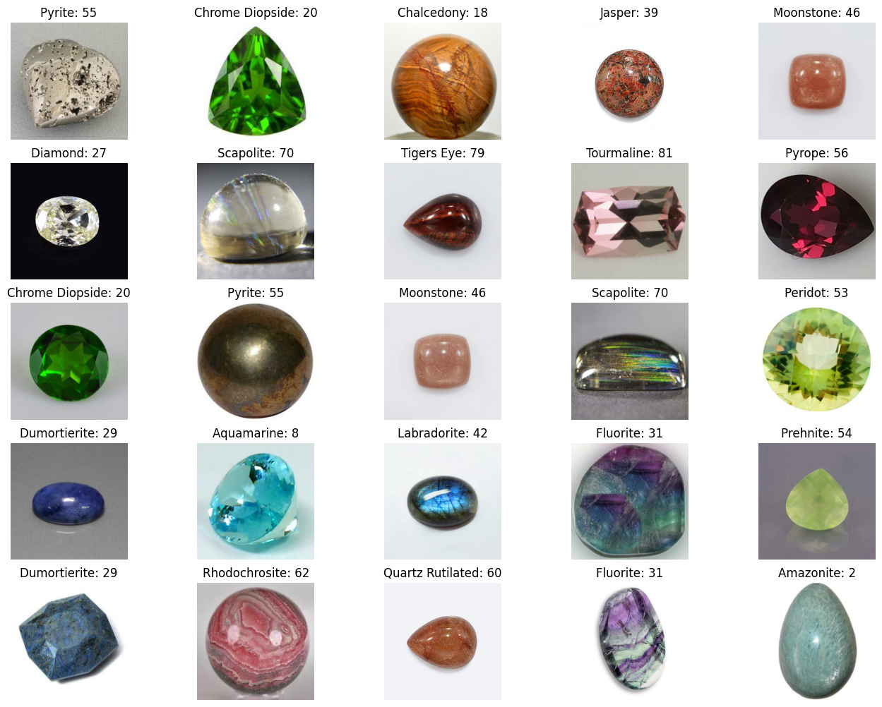
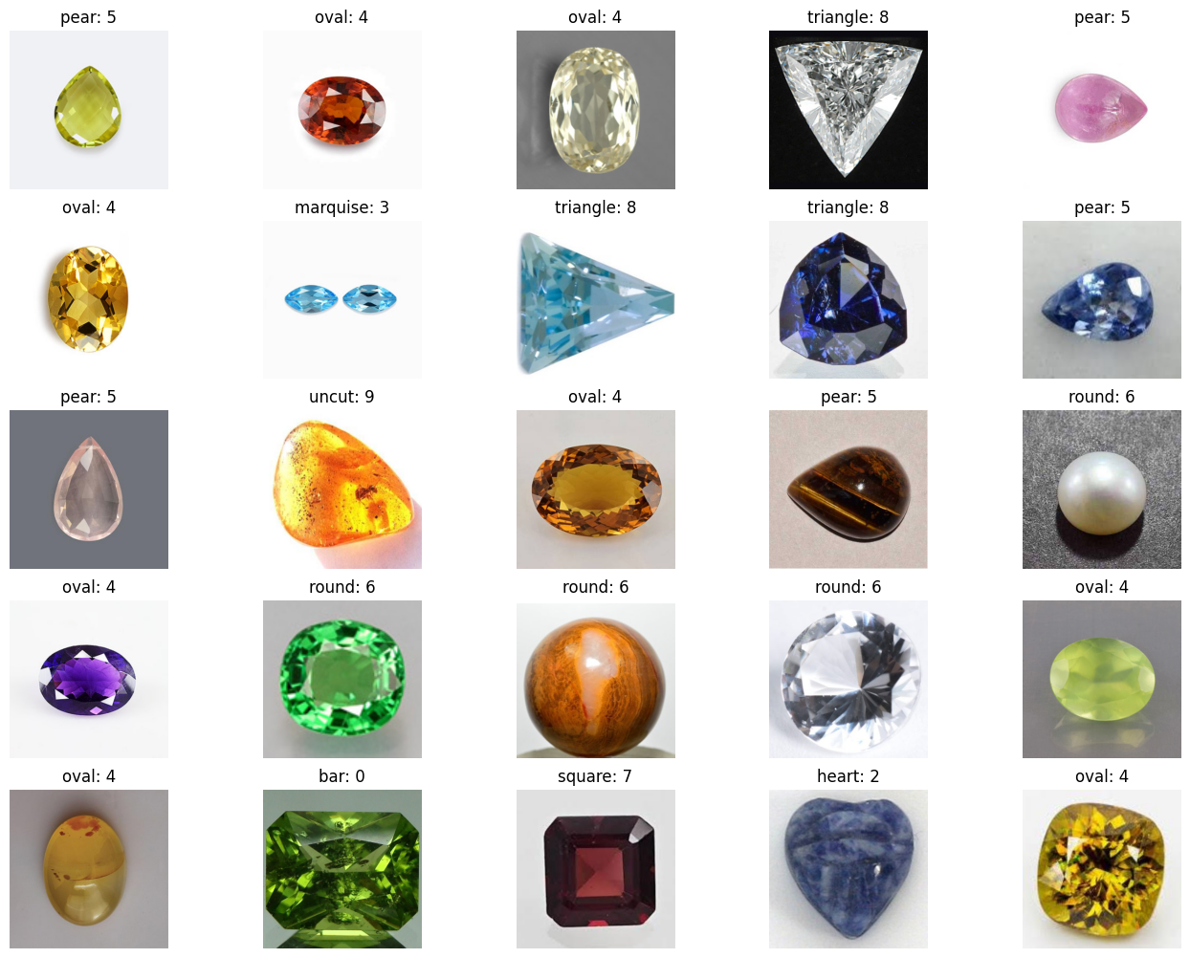
Model Architecture

The study utilizes a Convolutional Neural Network (CNN) structure consisting of five main layers. Every layer has a vital function in facilitating the model's ability to accurately extract intricate data and consistently recognize gemstone images. Below is a detailed description of the model's structure, along with a visual representation of the network's architecture:
Input Layer: The input layer serves as the primary entry point for the gemstone images into the CNN model. Each image is represented as a grid of pixels that contains multiple channels, such as RGB channels.
The network structure has five convolutional layers. Following the input layer, the network has two successive sets of convolutional layers, resulting in a cumulative total of five layers.
The convolutional layers: These utilize trainable filters to conduct convolutions on the input pictures, extracting essential characteristics like as edges, textures, and patterns.
The convolutional layer comprises many filter kernels that convolve with the input images, producing feature maps that capture diverse characteristics of the visual material.
Nonlinear activation functions, such as ReLU, are applied to the output of each convolutional layer to introduce nonlinearity and enhance the model's capacity to represent data.
Level the layer: The feature maps undergo a transformation into a one-dimensional array with the use of the flatten layer, which follows the convolutional layers. This adjustment prepares the obtained attributes for future processing by succeeding layers.
Dropout layer: To address the issue of overfitting and improve generalization, a dropout layer is incorporated after the flattening step. During the training phase, this layer incorporates a stochastic dropout mechanism, which selectively disables a fraction of neurons. This methodology promotes the development of robust and flexible attributes in the neural network, while simultaneously reducing its reliance on specific neurons.
Dense layer: This also known as a fully linked layer, is a type of layer in a neural network where each neuron is connected to every neuron in the preceding layer.
The thick layer: This also known as a fully connected layer, is responsible for aggregating the received information and producing definitive predictions on the classification of gemstone images.
The function of this layer is to form synaptic connections between every individual neuron in the preceding layer and each individual neuron in the subsequent layer. This allows for the creation of complex combinations of characteristics and simplifies the process of generating categorization decisions.
Diagram depicting the model:

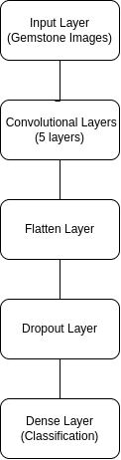

Classification Dense Layer: The input layer is comprised of photos of gemstones. Subsequently, these images are transmitted through a sequence of five convolutional layers. Subsequently, the results obtained from the convolutional layers are transformed into a flattened format. Subsequently, a dropout layer is included to mitigate the risk of overfitting. Ultimately, the compressed result is then sent into a compact layer for the purpose of categorization.
The diagram illustrates the flow of information in the CNN model, commencing at the input layer and traversing through the convolutional layers. Subsequently, the flattening, dropout, and dense layers are executed. This architectural style enables the model to effectively analyze gemstone images and precisely classify them.

EVALUATION
The proposed system achieves a 74% accuracy in name identification using CNN that the used dataset of 87 gemstone classes and 87% high accuracy in shape identification with 10 gemstone shape classes dataset. specifically for this research. The research evaluation process involved both quantitative methodology and qualitative methodology. After obtaining optimal results using different test methods in the testing phase, the research findings were compared with previous research in the field. The purpose of this evaluation step is to conduct a qualitative assessment using a thematic analysis based on input from domain and technical experts. Finding experts specializing in gemology and open to exploring advanced machine learning applications proved to be a significant challenge. Many in the gemstone industry rely on traditional methods of gemstone identification and valuation, and might be hesitant to adopt new technological solutions that promise to enhance accuracy and efficiency. Consequently, the author had to actively seek out gemology experts who were willing to explore the innovative use of machine learning to potentially revolutionize gemstone analysis and improve industry practices.
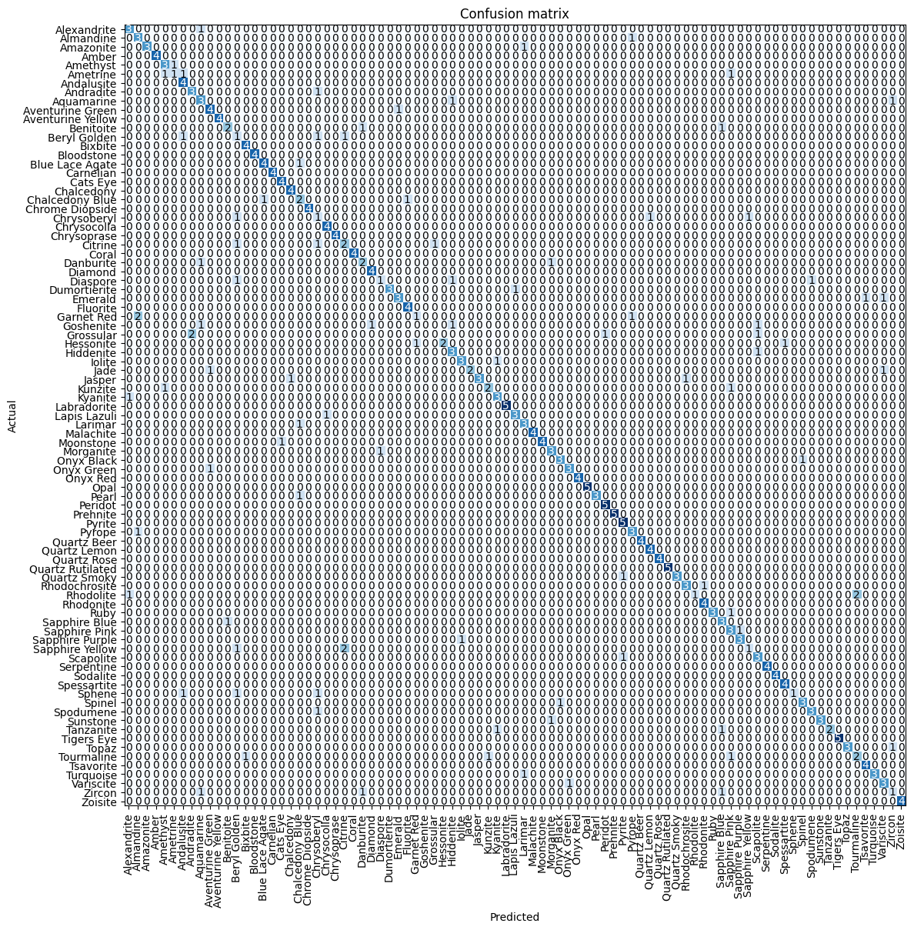
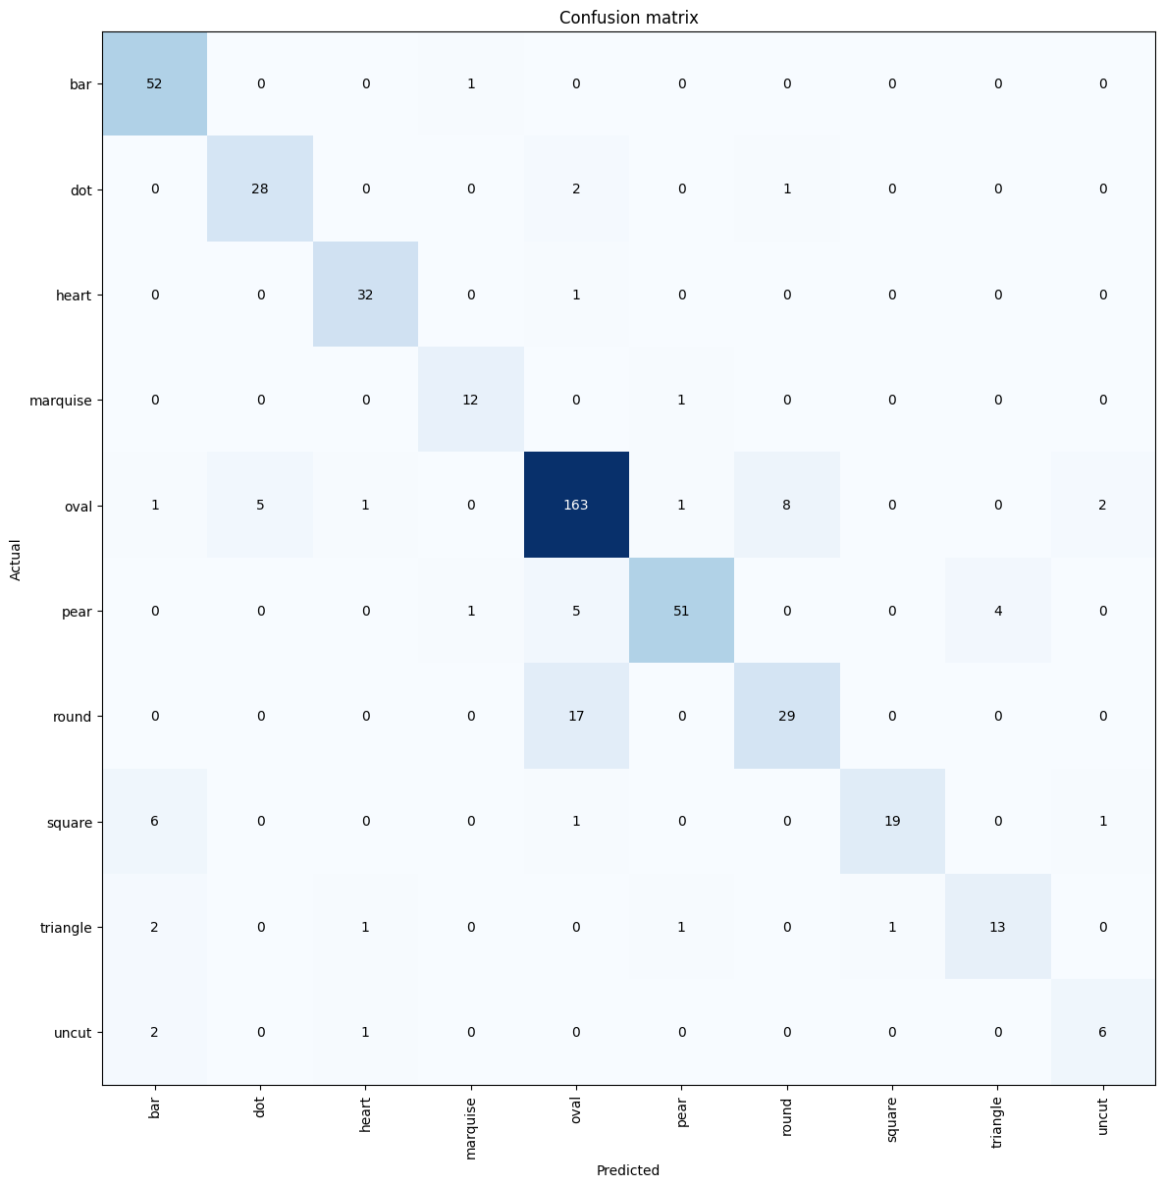

CONCLUSION

The goal of the proposed research is to design an automated system that makes use of cutting-edge imaging techniques in order to overcome the drawbacks of manual observation and reliance on sophisticated tools in gem identification. Achieving the ideal angle between the gem and the camera proved challenging, requiring the image to be captured from a high position above the shape of the gem. The viewing angle is precisely positioned above the gem, allowing you to see its high cut and the subtleties of its facets unobstructed.
Ambient light affects the quality of the image, causing the accuracy of the classification model to decrease are limitations of this research. Due to limited data availability, they were forced to place a limit on the labels.

FUTURE ENHANCEMENTS
Several significant advancements are expected in future iterations of machine learning techniques used to detect and determine the most suitable forms for unprocessed gemstones. Firstly, improvements in image recognition algorithms will allow for more precise analysis of gemstone characteristics straight from images, including small imperfections, variations in colour, and the orientation of the gem. This would enable more accurate advice for the optimal cutting techniques for each stone in order to enhance its aesthetic attractiveness and increase its market worth.
Moreover, integrating market trend data into the machine learning model will guarantee that the suggested gem designs are in line with current consumer tastes and market demands. This technique is not only scientifically sound but also economically feasible.
By employing deep learning techniques, the model's predictions will be enhanced, allowing it to acquire knowledge from a wider range of gemstone attributes and cutting results. The ongoing process of learning, driven by a constantly growing collection of gemstone cutting and their market performance, will gradually enhance the precision and dependability of the shape suggestions.
Finally, involving gemology specialists during the construction and training stages of the model will include centuries of traditional knowledge into the system, combining the accuracy of machine learning with the insight of human wisdom. This collaborative method will enhance the art of gemstone cutting to unprecedented levels, guaranteeing that any unprocessed gemstone may be turned into a work of art that showcases brilliance and vibrancy.

REFERENCES

Chow, B. and Reyes-Aldasoro, C. (2021). Automatic Gemstone Classification Using Computer Vision. Minerals, 12(1), p.60. Available at: https://doi.org/10.3390/min12010060
Sandro Izidoro and Erick Oliveira Rodrigues. (2020) Machine learning applied to emerald gemstone grading: framework proposal and creation of a public dataset Available at: https://www.researchgate.net/publication/356729804_Machine_learning_applied_to_emerald_gemstone_grading_framework_proposal_and_creation_of_a_public_dataset
Thabitta Judixon(2022) Gemstone Classification using Convolutional Neural Network
Available at: https://www.ijert.org/research/gemstone-classification-using-convolutional-neural-network-IJERTV12IS050214.pdf
Shigley, J.E. (2008) ‘A review of current challenges for the identification of gemstones’, Geologija, 50(4), pp. 227–236. Available at: https://doi.org/10.2478/v10056-008-0048-8
‌Maula, I. et al. (2018) ‘Development of a Gemstone Type Identification System Based on HSV Space Colour Using an Artificial Neural Network Back Propagation Algorithm’, 149(Icosat 2017), pp. 104–109. Available at: https://doi.org/10.2991/icosat-17.2018.24
www.gia.eduhttps. (n.d.). Gem Buyers Beware: Get Rich Quick Scams. [online] Available at: https://www.gia.edu/gia-news-research/get-rich-quick-gem-scams [Accessed 16 Oct. 2023].
www.gemstones.com. (n.d.). Gemstone Identification: How to Identify Gemstones | Gemstones.com. [online] Available at: https://www.gemstones.com/articles/gemstone-how-to-identify.
Pereira, A C., Carvalho, P., Coelho, G., & Corte-Real, L. (2019, January 1). Efficient CIEDE2000-based Color Similarity Decision for Computer Vision. Available at:
https://scite.ai/reports/10.1109/tcsvt.2019.2914969 [Accessed 15 Oct. 2023].
https://www.researchgate.net/publication/356729804_Machine_learning_applied_to_emerald_gemstone_grading_framework_proposal_and_creation_of_a_public_dataset/link/62fe4c87aa4b1206fabd0e60/download (Machine learning applied to emerald gemstone grading: framework proposal and creation of a public dataset , Fena, F.B & Crabi. D 2022)

Maula, I. et al. (2018) 'Development of a Gemstone Type Identification System Based on HSV Space Colour Using an Artificial Neural Network Back Propagation Algorithm,' Development of a Gemstone Type Identification System Based on HSV Space Colour Using an Artificial Neural Network Back Propagation Algorithm. https://doi.org/10.2991/icosat-17.2018.24. Maula et al. (2018)
Willian M. Freire; Aline M. M. M. Amaral; Yandre M. G. Costa (2022)Gemstone classification using ConvNet with transfer learning and fine-tuning, Available at: https://doi.org/10.1109/IWSSIP55020.2022.9854441.
Mol, A.A., Martins-Filho, L.S., da Silva, J.D.S. and Rocha, R. (2007). Efficiency parameters estimation in gemstones cut design using artificial neural networks. Computational Materials Science, 38(4), pp.727–736. doi:https://doi.org/10.1016/j.commatsci.2006.05.012.
Khalid K., Al-jabery, and Donald C. Wunsch II, (n.d.). Data Preprocessing. https://www.sciencedirect.com/topics/engineering/data-preprocessing#:~:text=Data%20preprocessing%20is%20an%20iterative,while%20containing%20errors%20%5B37%5D.
What is Random Forest? | IBM (no date). https://www.ibm.com/topics/random-forest.[Accessed 20 NOV. 2023]
Brownlee, J. (2021) How to Code a Neural Network with Backpropagation In Python (from scratch).https://machinelearningmastery.com/implement-backpropagation-algorithm-scratch-python/#:~:text=The%20Backpropagation%20algorithm%20is%20a,neural%20cells%2C%20called%20a%20neuron Brownlee (2021)[Accessed 20 NOV. 2023]
What is Linear Regression?- Spiceworks - Spiceworks (2023). https://www.spiceworks.com/tech/artificial-intelligence/articles/what-is-linear-regression/#:~:text=Linear%20regression%20is%20an%20algorithm,machine%20learning%20for%20predictive%20analysis (Kanade. V,2023)[Accessed 20 NOV. 2023]
MOSCOW Prioritization (2022). https://www.productplan.com/glossary/moscow-prioritization/ (MOSCOW Prioritization, 2022)[Accessed 20 NOV. 2023]
www.gemstones.com. (n.d.). Gemstone Identification: How to Identify Gemstones | Gemstones.com. [online] Available at: https://www.gemstones.com/articles/gemstone-how-to-identify.
Mol, A.A., Martins-Filho, L.S., da Silva, J.D.S. and Rocha, R. (2007). Efficiency parameters estimation in gemstones cut design using artificial neural networks. Computational Materials Science, 38(4), pp.727–736. doi:https://doi.org/10.1016/j.commatsci.2006.05.012.
www.superdatascience.com. (n.d.). SuperDataScience. [online] Available at: https://www.superdatascience.com/blogs/convolutional-neural-networks-cnn-step-1b-relu-layer.
McCombes, S. and George, T. (2022). How to Write Research Methodology in Four Steps | with Examples. [online] Scribbr. Available at: https://www.scribbr.com/dissertation/methodology/.
TensorFlow (2019). Convolutional Neural Network (CNN) | TensorFlow Core. [online] TensorFlow. Available at: https://www.tensorflow.org/tutorials/images/cnn.
Guobin Ou, Yi Lu Murphey. (2007). Multi-class pattern classification using neural networks.
Pattern Recognition, 40(1), pp.4–18. doi:https://doi.org/10.1016/j.patcog.2006.04.041.
Tanha, J., Abdi, Y., Samadi, N., Razzaghi, N. and Asadpour, M. (2020). Boosting methods for multi-class imbalanced data classification: an experimental review. Journal of Big Data, 7(1). doi:https://doi.org/10.1186/s40537-020-00349-y.
Gemdat.org. (2021). Gemstone Database - Gems and gemology, Gem Localities, Photos and Data. [online] Available at: https://www.gemdat.org/.

